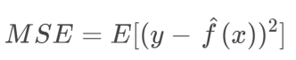

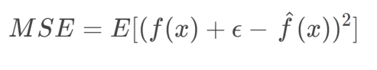

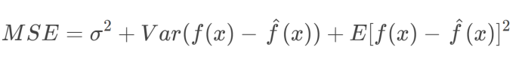

MSE (Prediction error) = Variance + Bias2 + Variance of Irreducible noise